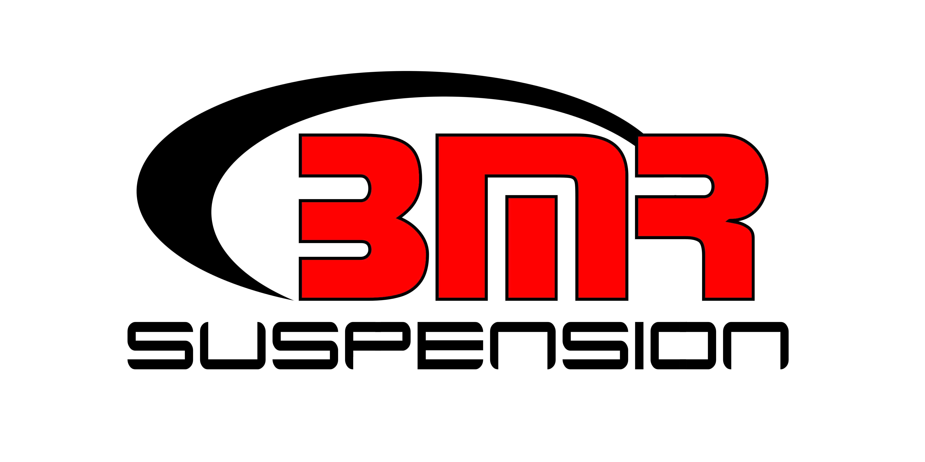

FOR IMMEDIATE RELEASE

BMR Suspension A-Arms for 1964-1972 GM A-Body

AAK401 - $769.95
AAK402 - $829.95

Improve handling and front-end stability in your 1964-1972 GM A-Body with a set of tubular A-arms from BMR Suspension. Manufactured from 1.25” and 1.5” DOM tubing and laser cut 3/16” mounting plates, both arms feature low-deflection, internally-fluted Delrin bushings with easy-to-access grease fittings. BMR Upper A-arms (AAU401/AA028) feature shorter tubes and offset cross-shafts to provide a shorter shim stack for lowered vehicles. The BMR Lower A-arms (AAL401) feature a CNC-machined ball joint cup with additional clearance for late model brake kits. BMR’s AAK401/AAK402 Upper and Lower A-arms greatly improve steering feel and response in normal and performance driving. Upgraded Delrin bushings add a solid, more responsive feel, compared to stock rubber bushings. The BMR A-arms (AAK401) is equipped with a standard ball joint on the upper A-arm, while the BMR A-arms (AAK402) is equipped with a tall ball joint on the upper A-arm. The upper A-arms (AAU401, AA028) and the lower A-arm (AAL401) can also be purchased individually. BMR has designed the AAK401/AAK402 for street performance, drag race, and handling applications, Available in red and black hammertone powdercoat finishes for long lasting good looks. Installation time is about 4-5 hours. Proudly made in the USA!

To preview all of BMR’s high-performance suspension parts, please visit www.bmrsuspension.com, email sales@bmrsuspension.com, or contact them at BMR Suspension, 928 Sligh Avenue, Seffner, FL 33584, 813-986-9302, Fax: 813-986-8055.

